

PART A – WEBSITE SPECIFICATION DOCUMENT
A. Website Objective and Business Goals
The primary goal of Sanele Timepieces is to design a sophisticated digital platform that presents luxury watches in a manner that reflects their quality and precision. From a business perspective, the website seeks to bridge the gap between traditional watchmaking and modern online availability for its customers. In line with industry standards for high-end retail, a strong digital presence is essential for building the brand equity and effective storytelling. The platform aims to establish strong customer relationships through immersive brand experiences while enhancing lead generation by enabling clients to reserve personal viewings through an online system/platform.
B. Target Audience
Demographics:
The target audience includes affluent individuals such as professionals and watch collectors between the ages of 25 and 60. These users appreciate and value exclusivity, detailed engineering, and refined modern and traditional design.
Technical Aptitude:
Users are comfortable and very much understand technology and extensively use high-end smartphones and laptops. They expect fast-loading pages, smooth navigation, and modern user interface designs, and are unlikely to tolerate slow or poorly functioning websites. To meet these expectations, the site follows the "3-Click Rule" a web design standard ensuring that any piece of information or product detail is accessible or found within three mouse clicks from the homepage, minimizing user frustration and mirroring the efficient, high-end service found in a physical luxury boutique.

C. Website Type and Content
Sanele Timepieces offers modern electronic catalogue combined with a brand storytelling platform. Its content includes:
          - Visual Content: High-quality images optimized for performance and including W3C standard alt text for accessibility.
          - Technical Information: Detailed specifications of each watch, such as materials for the dials, similar design references, and materials used in constructing the cases .
          - Interactive Features: An HTML5 based contact form that allows users to submit inquiries and feedback (which can be done in the contact page).

2. Information Design & Taxonomy
The website follows a hierarchical and progressively structured approach to present information in a logical and understandable manner. Content is sectioned into major categories such as Collections, Brand History, and Customer Care Services, allowing users to locate information easily without having to navigate through extensive amount of information. The navigation is designed around the 3-click rule, ensuring a clear structure of pages with easy access to content
- Navigation Flow: Home, About, Collection, Service, Contact/Feedback
  - Global Navigation: A consistent menu navigation bar that appears on every page, enabling a persistent navigation path (which mimics the web structure type of layout), high usability, and allowing users to move easily throughout the site at any time at any page they are at.
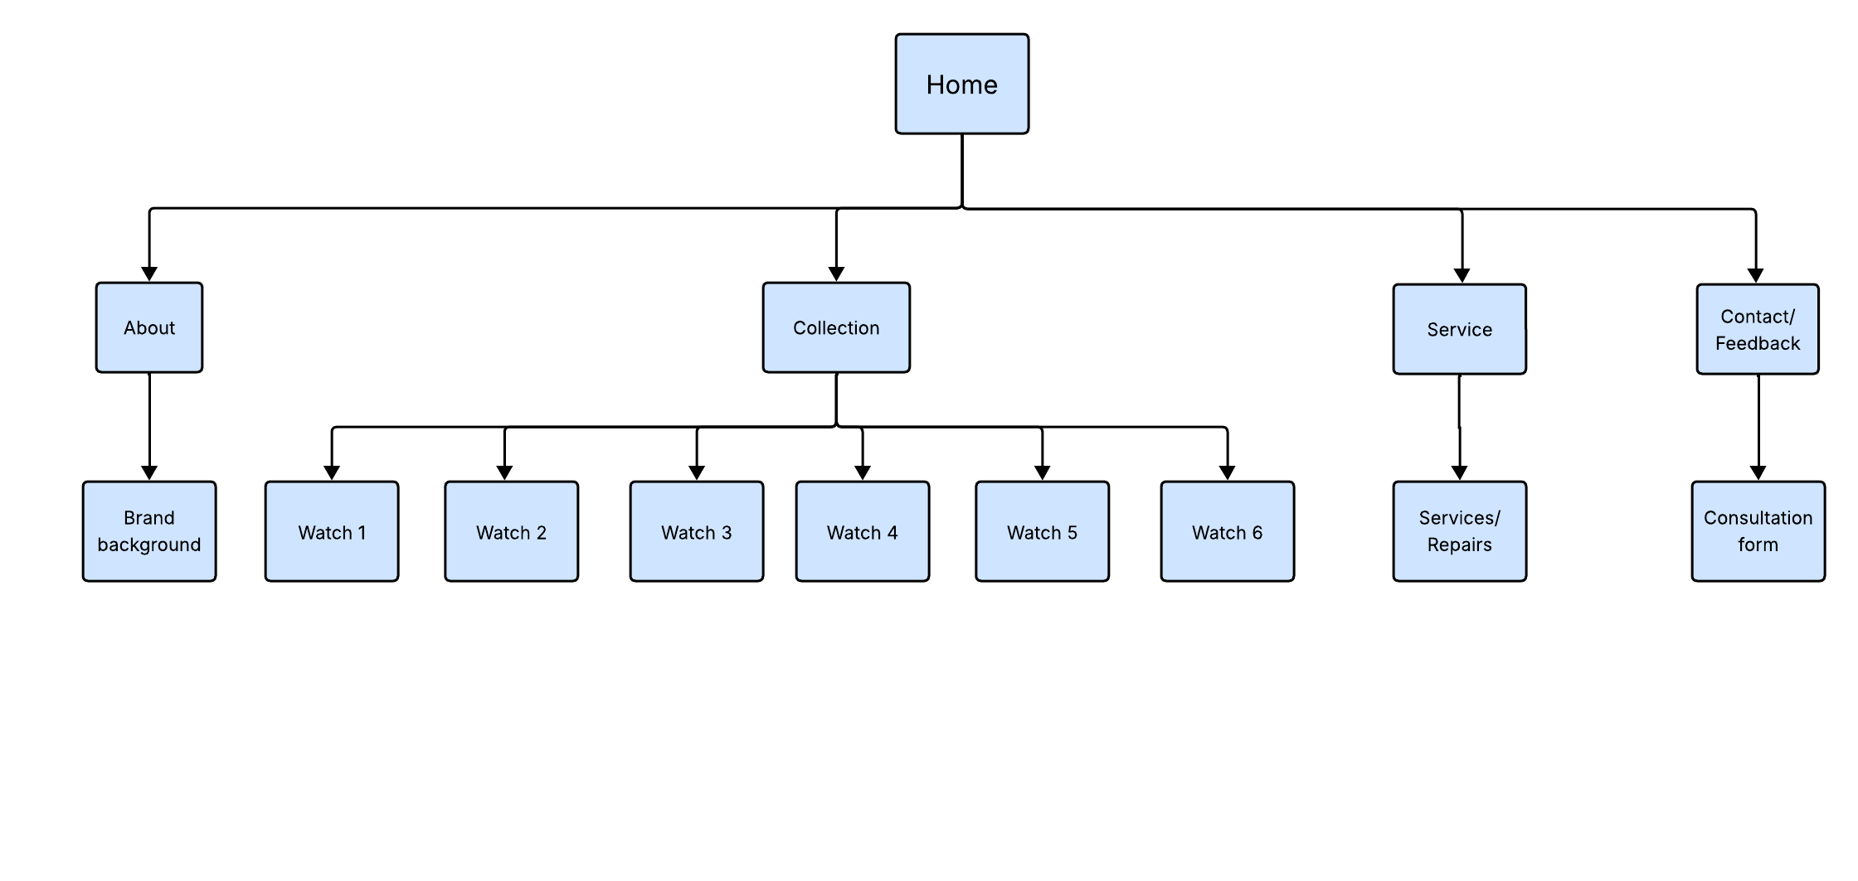

3. Page Template Design
The website uses a unified template (a single blueprint defining the common layout) to maintain consistency across all pages, which helps build user trust through visual familiarity.
- Layout Structure: The design is consistent throughout all the pages of website.
- Mock-up design: it shows a rough presentation of how the website will be structured and some of the details that will be added.
- Wireframe Design:
  - Home Page: Uses a hero section to capture user attention immediately.
  - Contact Page: Features a simple, centred form layout to encourage user interaction.
- Visual Design: The use of active white space is intentional and strictly maintained between elements. This is a core principle of luxury design, ensuring that the visual focus remains entirely on the high-end products without visual clutter.

Mock-up Designs
Opening page
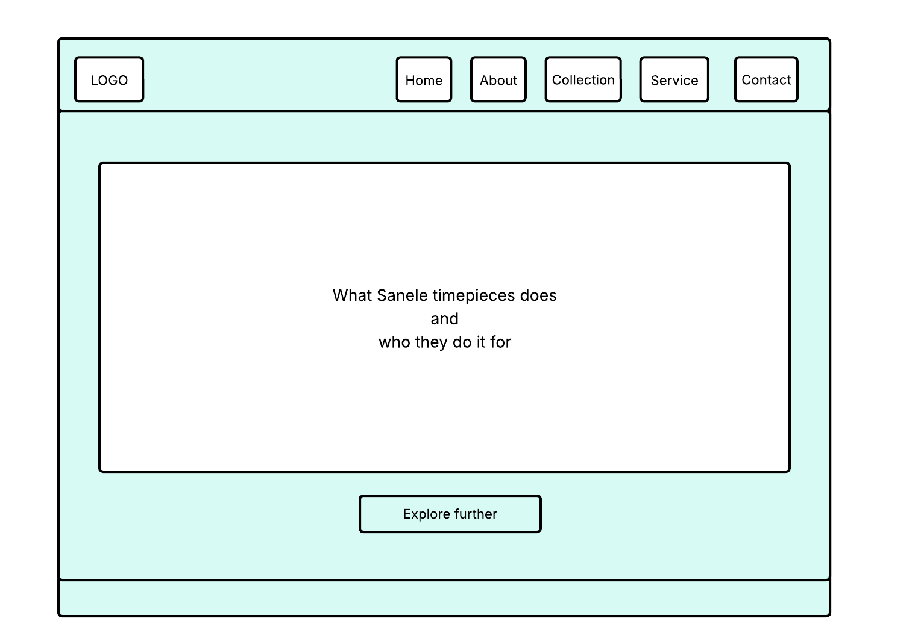
Home page
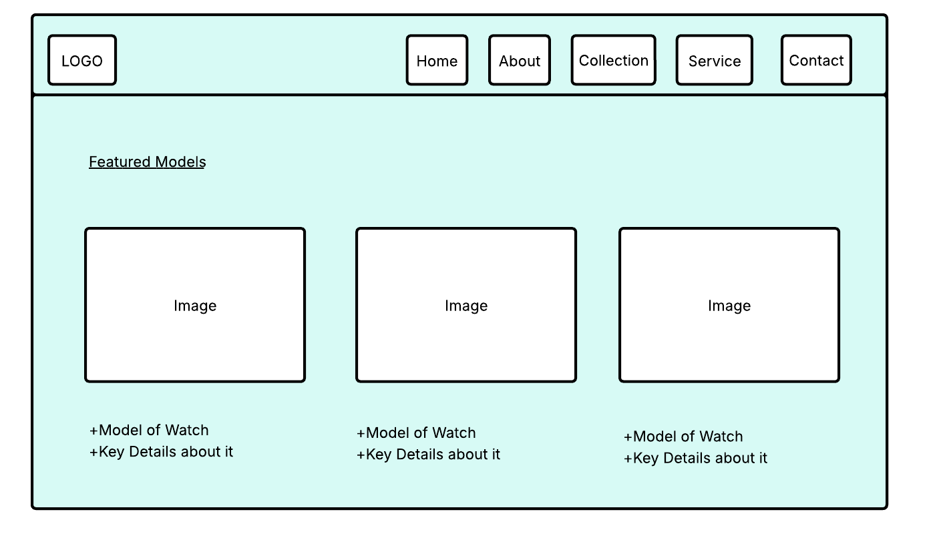
About page
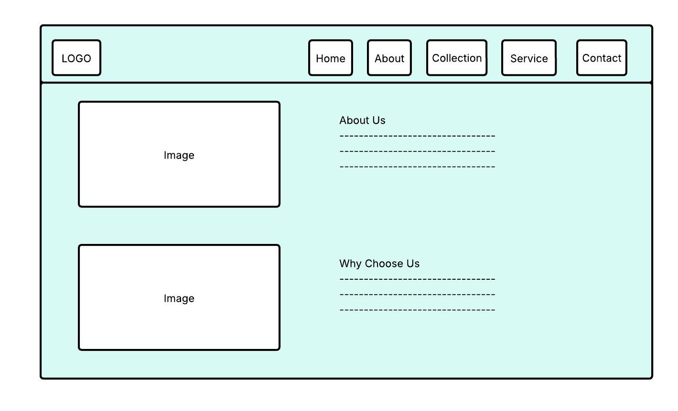
Collection
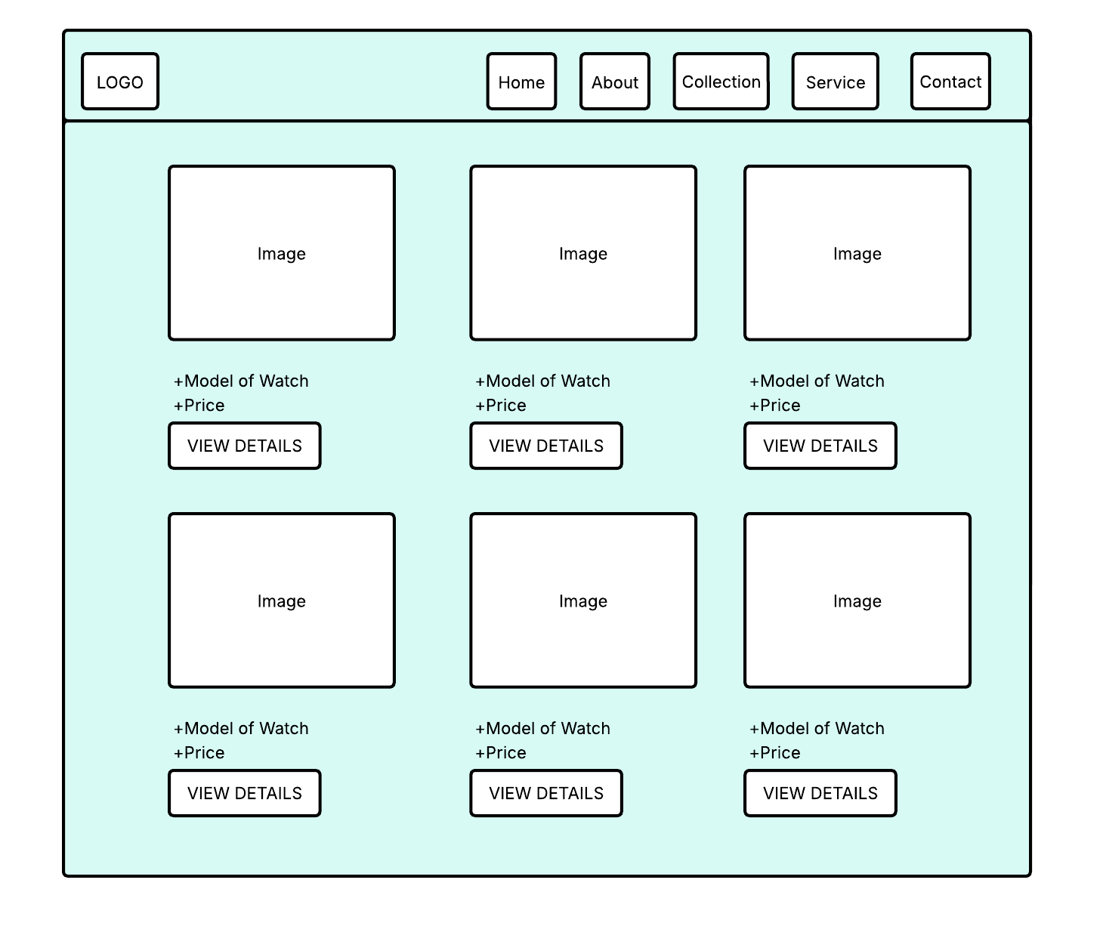
Service page
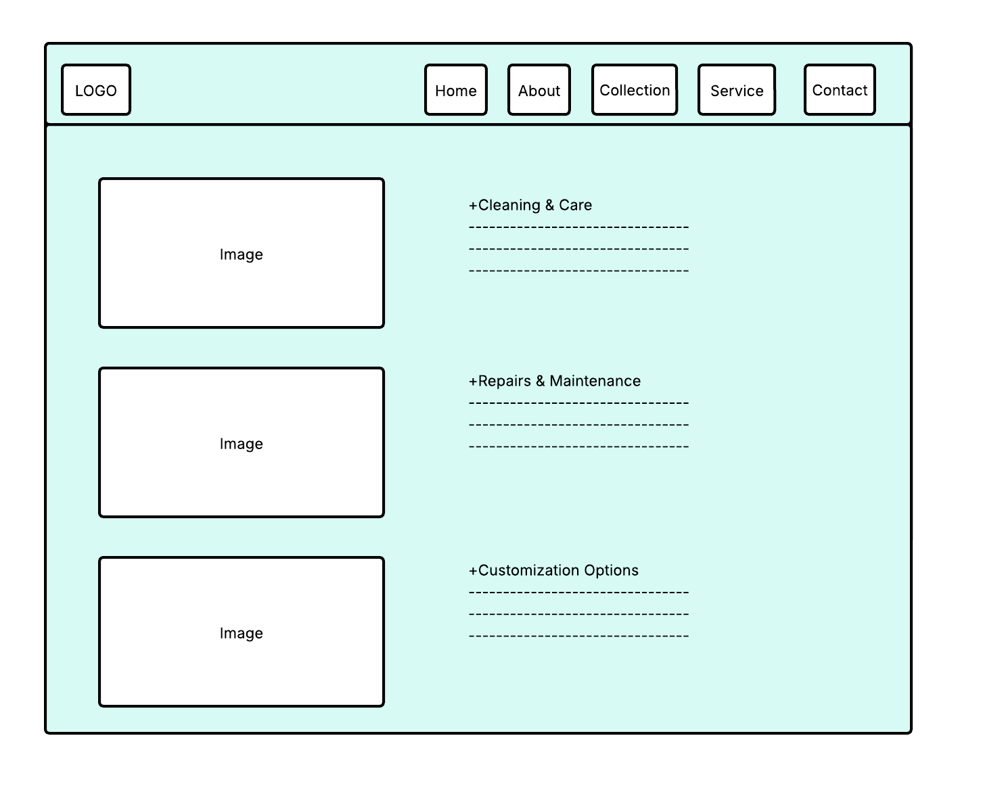
Contact page.

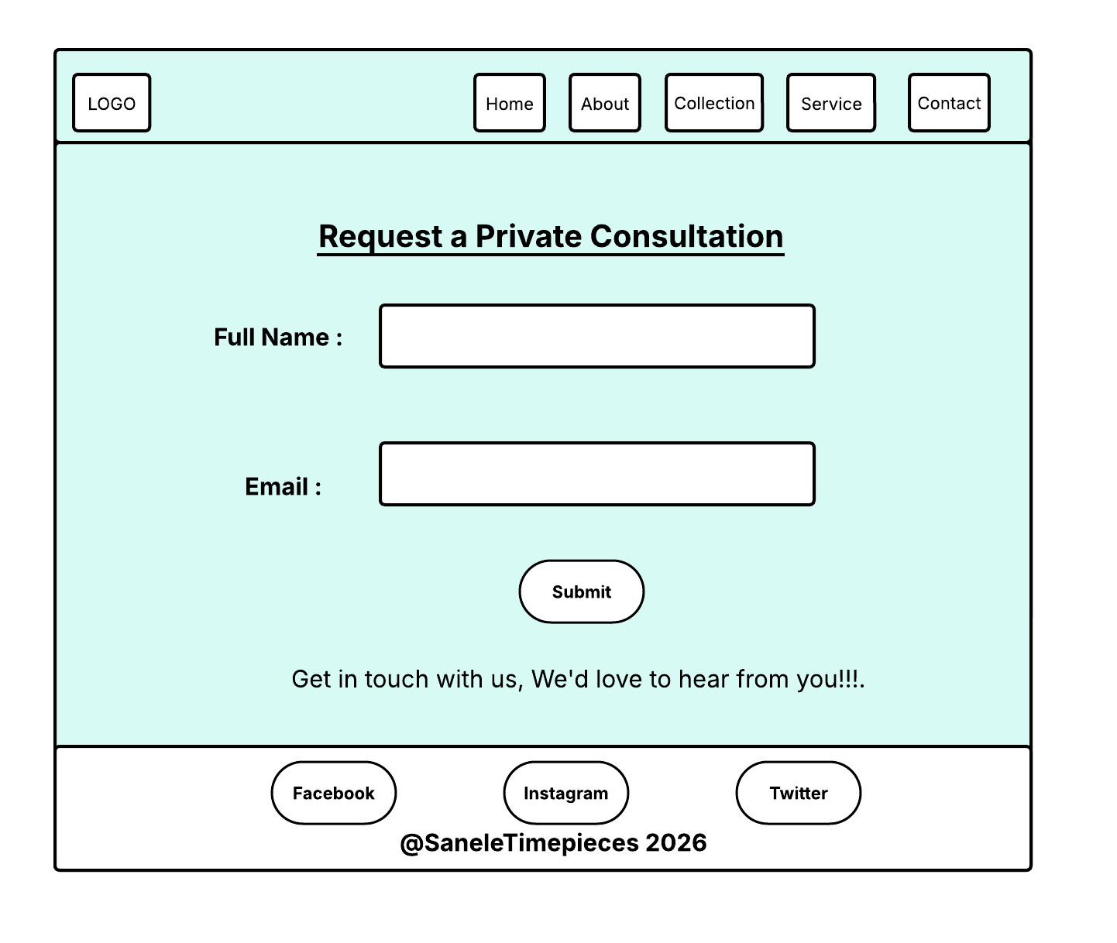

Wireframe Designs
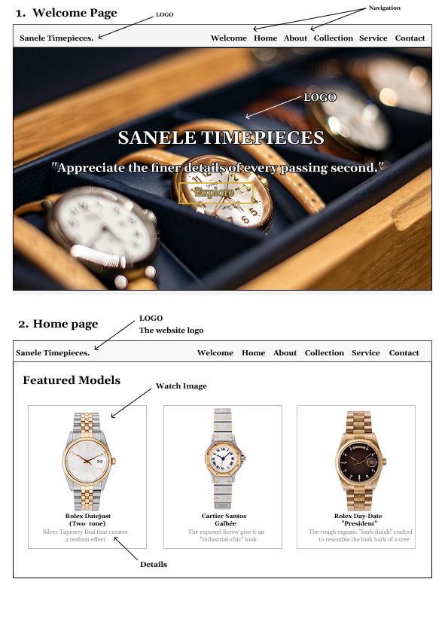

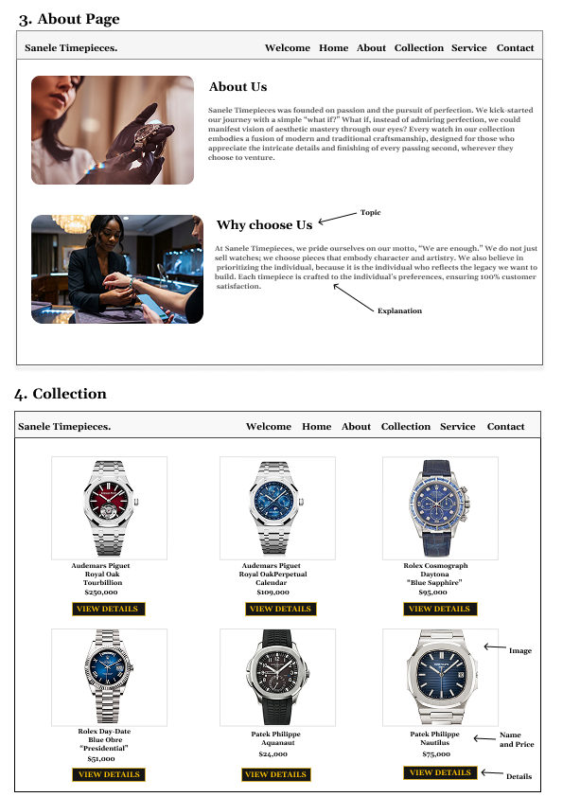

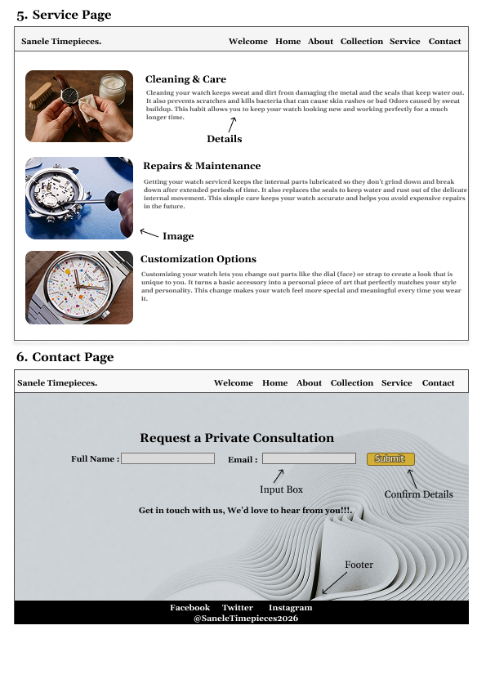
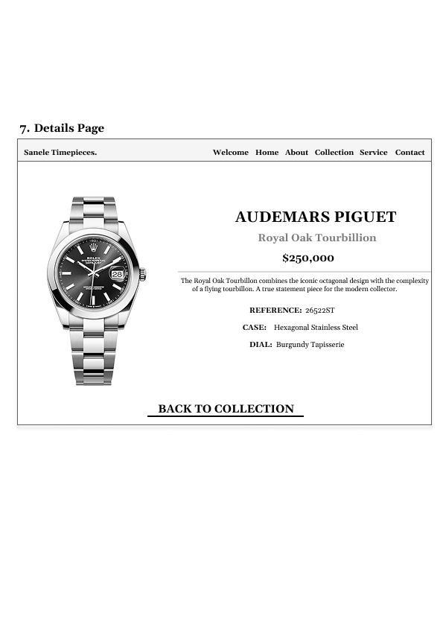

- Typography selection
- Georgia (Serif)
The font is generally used by a lot of established institutions as well as history. The font choice for a brand such as Sanele Timepieces suggests that there is a long legacy behind it that is accompanied by skilled craftsmanship. The font also gives of refined look while also being readable.

- Theme Choice
The layout of the website focuses more on the colour combination (It uses white, Gold and black) being used for the look of the website. The white background and watch images allow for each individual watch to standout on each page without competing.

The hover effect of the navigation turns Gold when the cursor is above it. The colour gives off the feeling of wealth and high-quality materials.

- Hero Image Choice
The background image on the landing page gives off the feeling that the atmosphere you have walked into is like that of which you are walking into a high-end shop.
- The Choice of Images
The images chosen are of high quality to suit what the users needs. They get enough time to look at each image and how it stands out boldly on each of the pages immersing them into wanting to continue to absorb the website deliverables.
- Website Layout
The website is designed based off the web structure format/plan (the layout allows the user to return to the index (landing page) from anywhere on the website making it easier to navigate. By pressing the logo, users expect it to act as a reset point as it is common in majority of websites and without it the website can feel broken to its users.

4. Technical Brief
The website is developed using modern technologies to ensure performance and responsiveness:
- Languages: HTML5 is used for semantic structure, while CSS3 is applied for styling elements such as typography, fonts, colours, and custom animations.
- Framework: Bootstraps is used for its mobile-first responsive grid system, simplifying layout design and ensuring the site functions perfectly on all devices.
- Graphics Tools: GIMP is used to edit and optimize images, reducing file sizes while maintaining high visual quality to improve page load speeds.
- Development Tools: Visual Studio Code is used for coding, and GitHub is used for robust version control and project management.

5. Quality Assurance
To ensure the site provides a high-quality user experience and functions properly, the following testing techniques are implemented:
- Cross-Browser Testing: The site is validated across Google Chrome, Safari, and Microsoft Edge to ensure consistent appearance, styling, and functionality.
- Responsive Testing: Chrome DevTools are utilized to simulate different viewport resolutions and verify the appearance on various screen sizes, including mobile, tablet, and desktop.
- Functionality Testing: The contact form is assessed to ensure all HTML5 "Required" attributes are functioning correctly and that submissions are processed without errors.

6. Publishing and Promotion
The website is hosted on GitHub Pages, providing reliable and fast hosting.
- Issue-Out Process:
- Initialize the local repository using git init.
- Stage and add all project files on the GitHub repository.
- Save changes with GitHub commit - "final submission ".
- Publish to the live server using GitHub.
- Live Website Link:
https://tumi065.github.io/cse25-326/
7. Future Developments/Recommendations
To enhance the website further, the following improvements are suggested:
- Search Feature: Add a search function to help users quickly find specific watch models.
- Performance Improvement: Implement "Lazy Loading" for images to reduce initial page load time, especially for users on slower mobile networks.
- Advanced Features: Introduction of a comparison feature that allows users to view and compare technical specifications of multiple watches side-by-side.

